 |  | TERMO DE ACEITE TÉCNICO
Solicitante: VIVO- Projeto Escolas Rurais
NOC/Operador: Rogerio Momi Frias |  |  | Cliente: VIVO
Empresa  EMC Brasil | VSAT-ID  VIVO-PER-31096164-MG |  | Link kbps  256/128 | Plataforma  VSAT
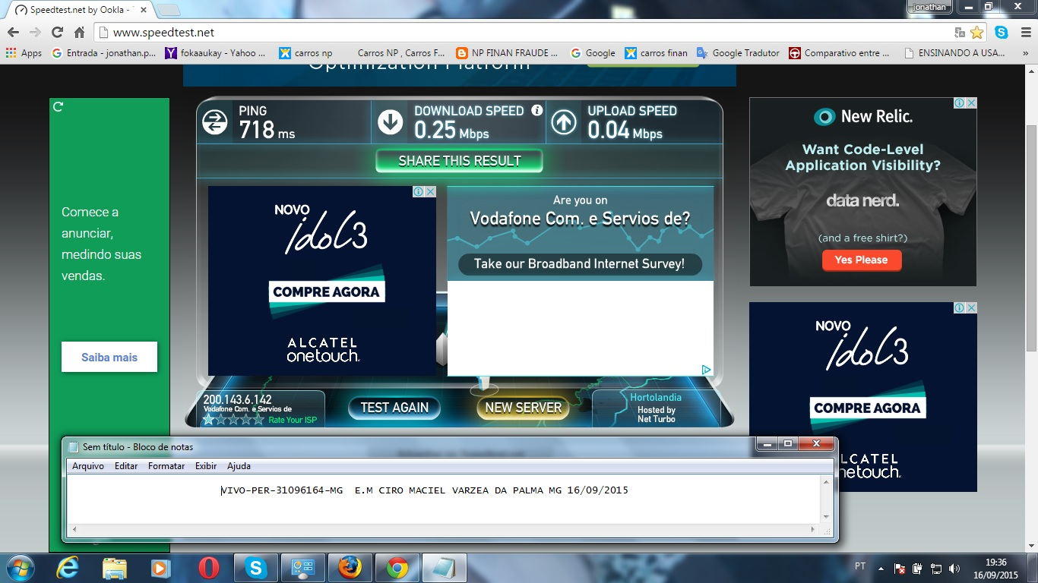
Satellite (DVB) RX Configuration
--------------------------------
Auto start : Enabled
Max MODCOD : 23 16APSK-9/10 (SNR threshold: 23.5 dB)
RX watchdog : 15 minute

Idx Pri SymbRate[Msps] Freq[GHz] Mode PopId Enable
* 0 0 9.320000 12.055825 DVB-S2 4 Yes
1 1 0.000000 0.000000 DVB-S2 2 Yes

Satellite (DVB) Receiver Status
--------------------------------
Rx State : On
DVB State : Forward link up
Network : 1326, GlobalIP@Telstar-14R
Frequency : 12.055706 GHz
Symbol Rate : 9.319998 Msps
S2 ModCod
- receiving : 4 QPSK-1/2
- current max : 23 16APSK-9/10
Pilot : On
Frame length : Short
DVB S2 Mode : ACM
Roll off : 0.25
SNR : 14.6 dB
Input Power : -33 dBm

Satellite (DVB) TX Configuration
--------------------------------
Auto start : Enabled
IDU Output Power : -30 dBm
IDU Max Output Power: 0.0 dBm
ODU Output Power : 33.7 dBm
EIRP : 47.0 dBW
Default CW Frequency: 0.000000 GHz
ATM mode : VC-Mux
Header Compression : None

Satellite (DVB) Transmitter Status
--------------------------------
State : On (TDMA)
IDU Output Power : -20.3 dBm
ODU Output Power : 33.2 dBm
EIRP : 46.5 dBW
Es/No : 14.0 dB
Header Compression : Disabled
Timing correction : -46 us (260988 us)
Frequency correction: -300 Hz

Pinging 10.29.2.33 with 32 bytes of data:

Reply from 10.29.2.33: bytes=32 time=1938ms TTL=61
Reply from 10.29.2.33: bytes=32 time=922ms TTL=61
Reply from 10.29.2.33: bytes=32 time=847ms TTL=61
Reply from 10.29.2.33: bytes=32 time=764ms TTL=61

Ping statistics for 10.29.2.33:
Packets: Sent = 4, Received = 4, Lost = 0 (0% loss),
Approximate round trip times in milli-seconds:
Minimum = 764ms, Maximum = 1938ms, Average = 1117ms

c:\>ping 10.53.0.145

Pinging 10.53.0.145 with 32 bytes of data:

Reply from 10.53.0.145: bytes=32 time=1934ms TTL=61
Reply from 10.53.0.145: bytes=32 time=1107ms TTL=61
Reply from 10.53.0.145: bytes=32 time=920ms TTL=61
Reply from 10.53.0.145: bytes=32 time=843ms TTL=61

Ping statistics for 10.53.0.145:
Packets: Sent = 4, Received = 4, Lost = 0 (0% loss),
Approximate round trip times in milli-seconds:
Minimum = 843ms, Maximum = 1934ms, Average = 1201ms

ping 8.8.8.8
64 bytes from 8.8.8.8: time=2460 ms
64 bytes from 8.8.8.8: time=930 ms
64 bytes from 8.8.8.8: time=1270 ms
64 bytes from 8.8.8.8: time=980 ms
64 bytes from 8.8.8.8: time=870 ms

--- 8.8.8.8 ping statistics ---
5 packets transmitted, 5 received, 0.00 percent packet loss
rtt min/avg/max = 870/1300/2460 ms

